New York Lender Paid Mortgage Tax
New York state has many quirks and complexities that must be accounted for when preparing the LE. One which is unique to New York is the portion of state mortgage tax that is paid by the lender. Except in certain circumstances, 0.25% of the loan amount is payable by the lender to New York state as a mortgage tax.

CEMA Transactions
One modification to this tax calculation is applied in CEMA transactions. CEMA is short for Consolidation, Extension and Modification Agreement. As such the mortgage tax amount is calculated on the new money amount; or in other words, the difference between the new loan amount and any unpaid debt. This offers a discount in total state mortgage tax due, which not only reduces the amount the buyer is responsible for, but also the lender paid portion.

Exemptions
There are also multiple exemptions that can apply to this tax. Under section 253 of New York State tax law, the state cannot collect taxes from a federal agency or entity, so if the lender is a Federal Credit Union the lender paid portion of the state mortgage tax is not assessed. Cooperative units are also exempt from mortgage tax since they are not considered real property, but instead shares in an organization, therefore no mortgage tax is due on these transactions. Lastly, the lender is not responsible for this portion of taxes if the transaction involves a commercial property, instead, the buyer must pay the amount assessed.
When entering the information to obtain a quote within the LodeStar Calculator, there are options to choose whether the lender is a federal credit union, if the property is a cooperative unit, or if the quote is for a CEMA transaction.
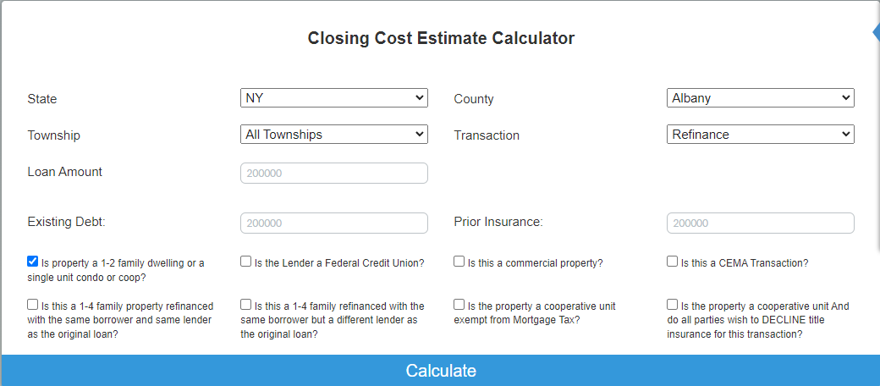

Once the necessary fields are provided the lender paid taxes will be listed in Section E as shown below. If there are no lender taxes to be paid, there will be nothing listed in the lender paid taxes portion of Section E.
